WOODPECKER CNC
Assembly Instructions
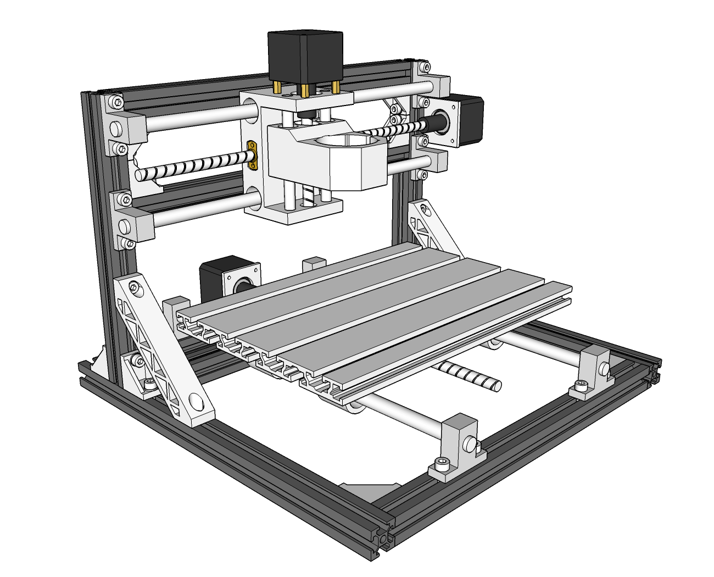
V2.5
- Size of some parts：
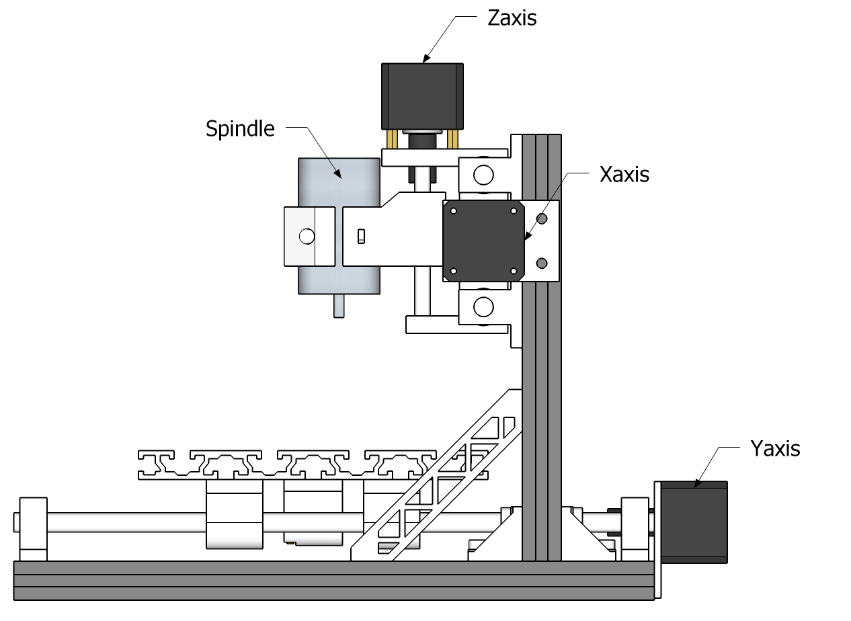
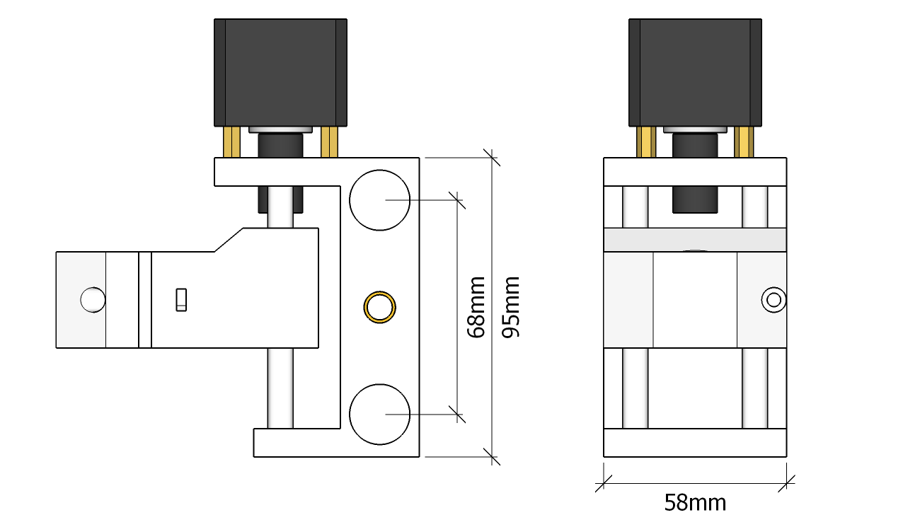
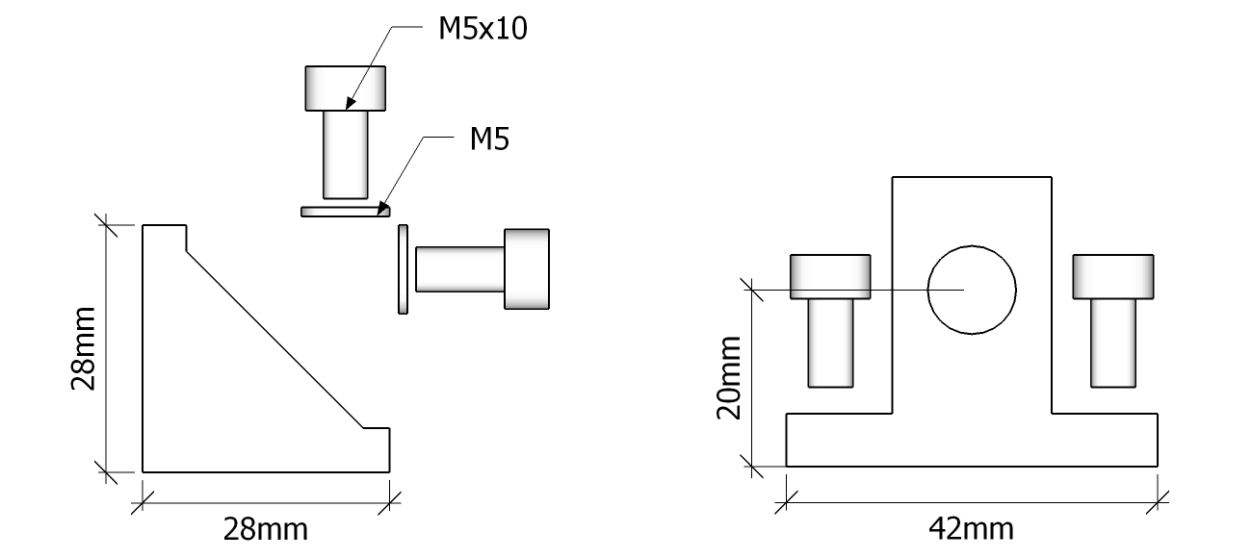
1. Frame 1
Base: 330mm×2、360mm×3、Angle Support×6、M5*10×12、Spacer×12
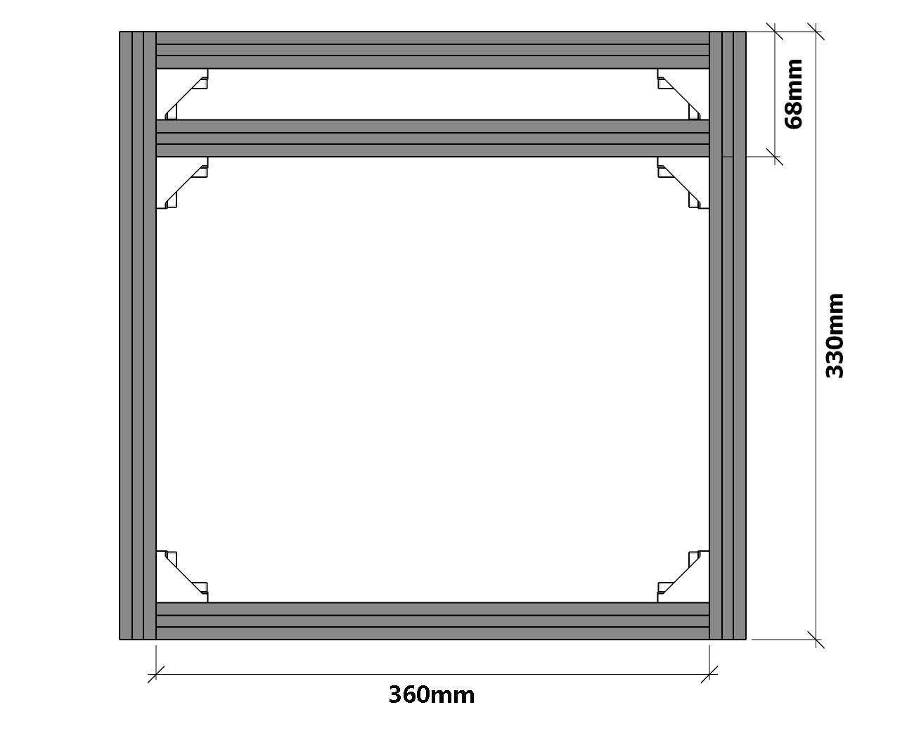
- Frame 2: 220mm×2、360mm×2、Angle Suport×4、M5*10×8、
Specer×8
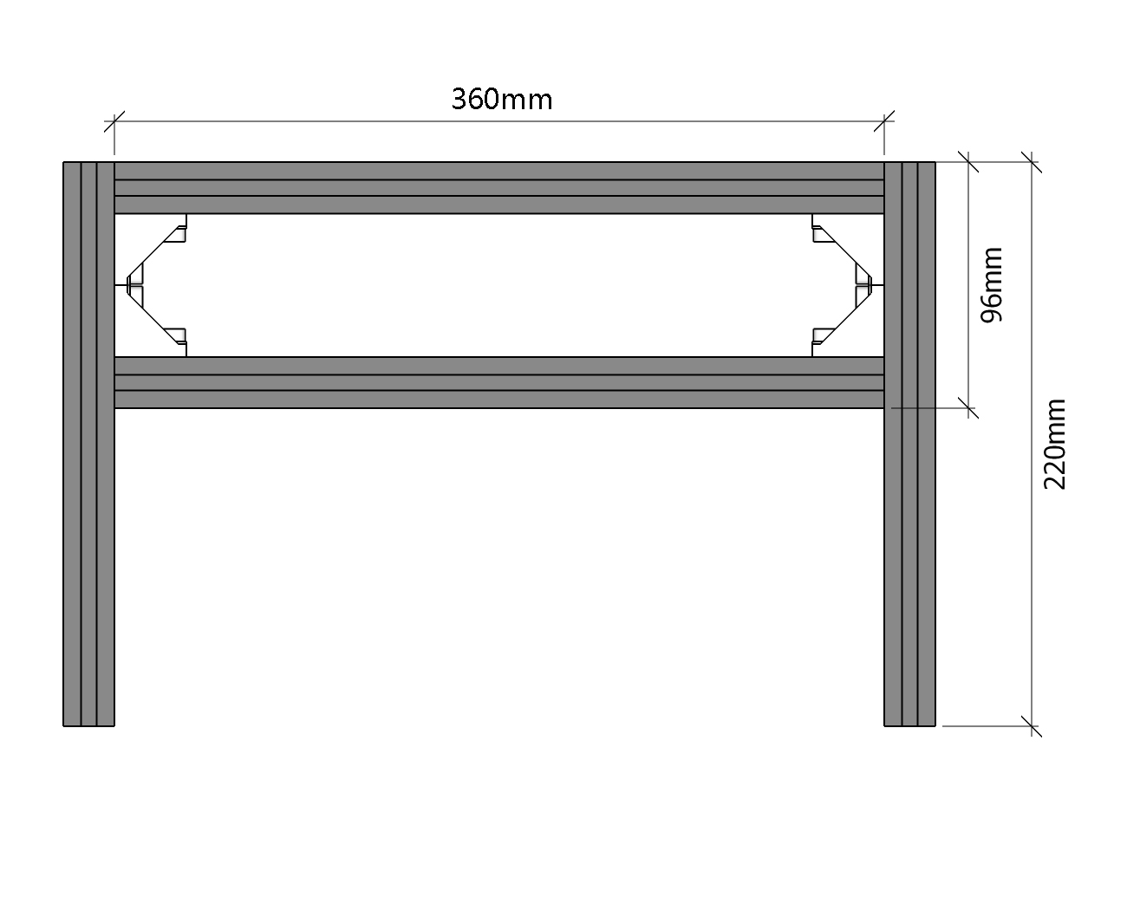

- Frame : Angle Support×6、M5*10×16、Spacer×12、Connecting pieces×2
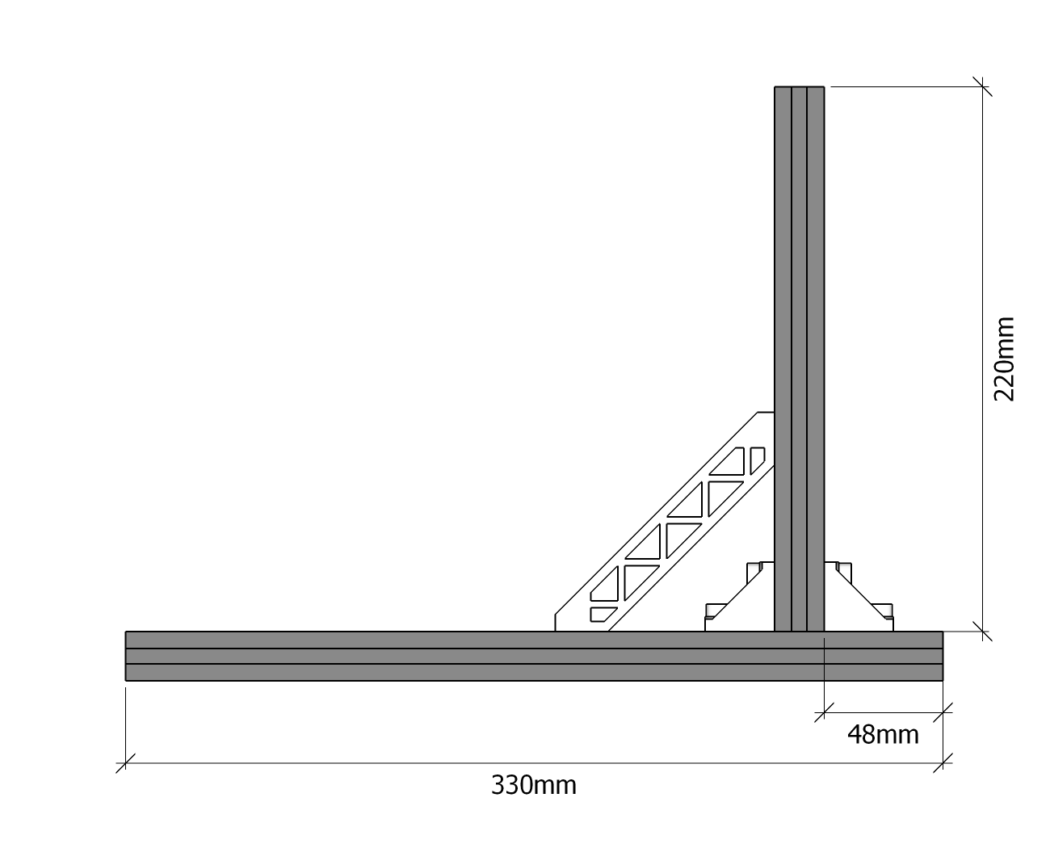
- Size of Polished Rod Supporting Base 1:
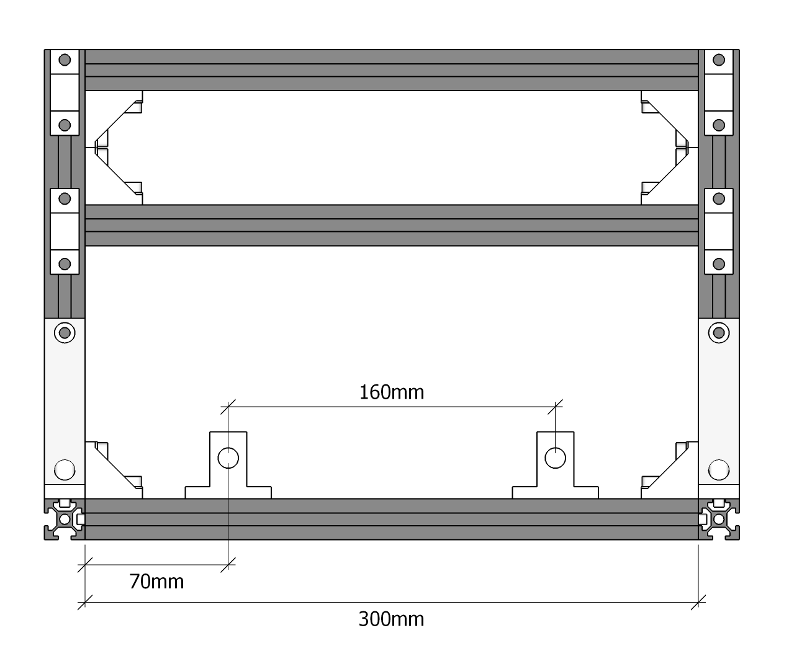
- Size of Polished Rod Supporting Base 2:
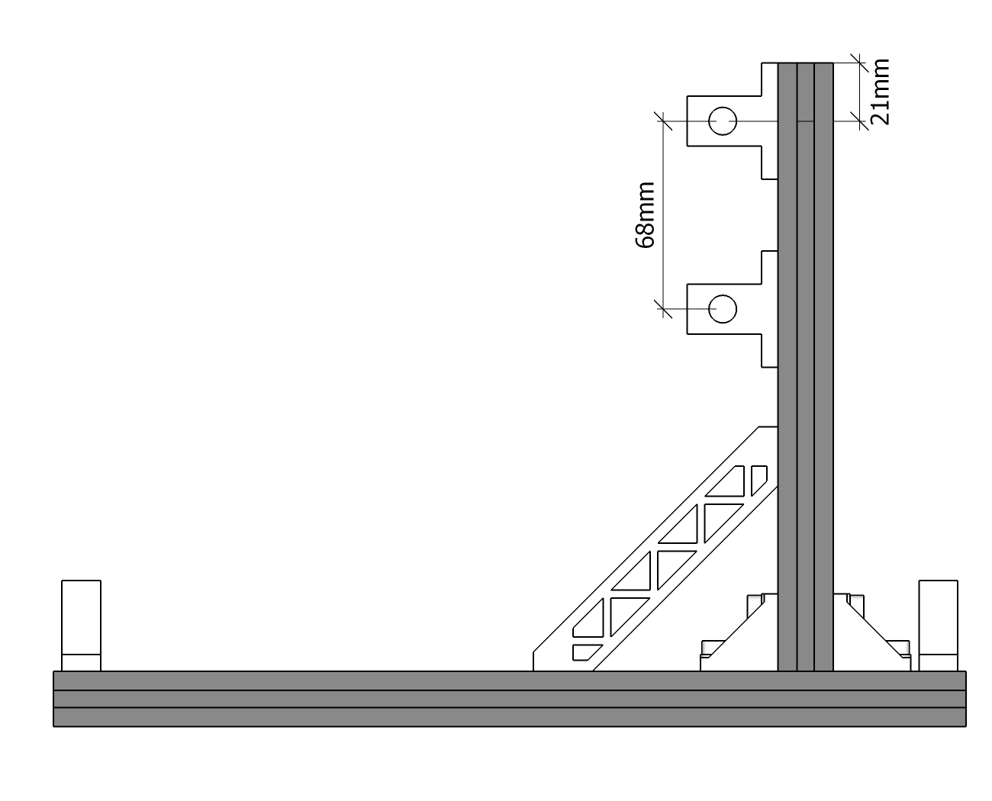
- Y-axis: M6*10×10、Sliding Block×5、Worktable×1
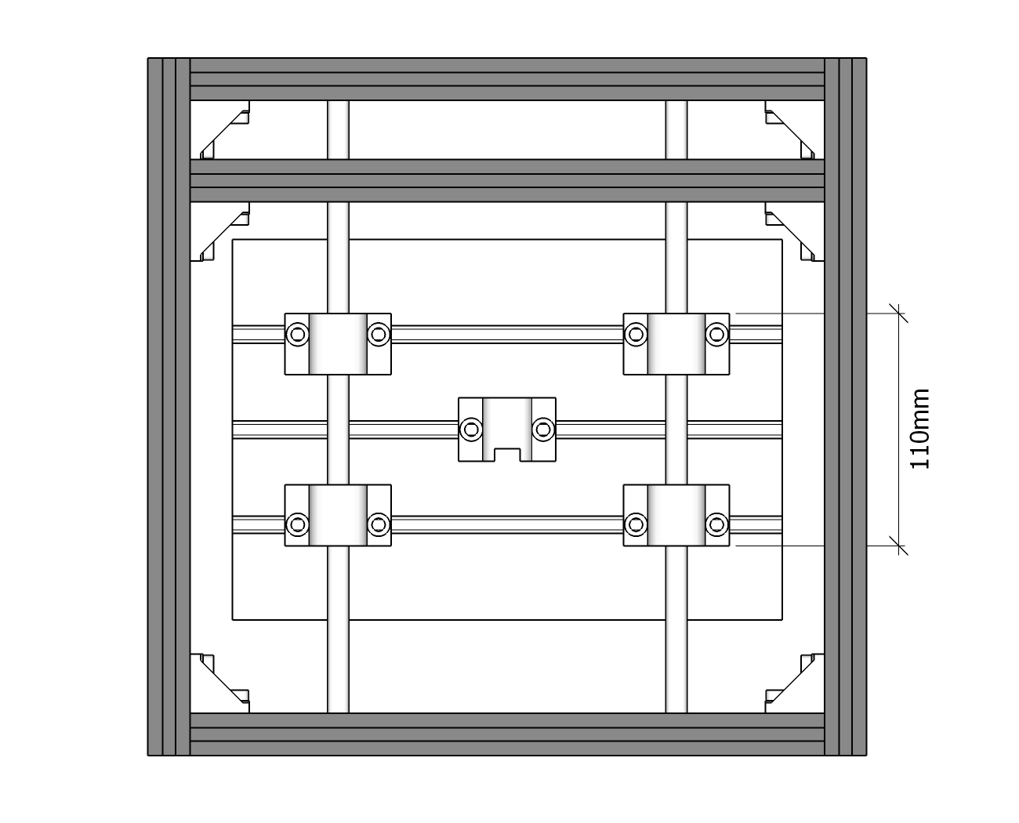
- Stepper Motor
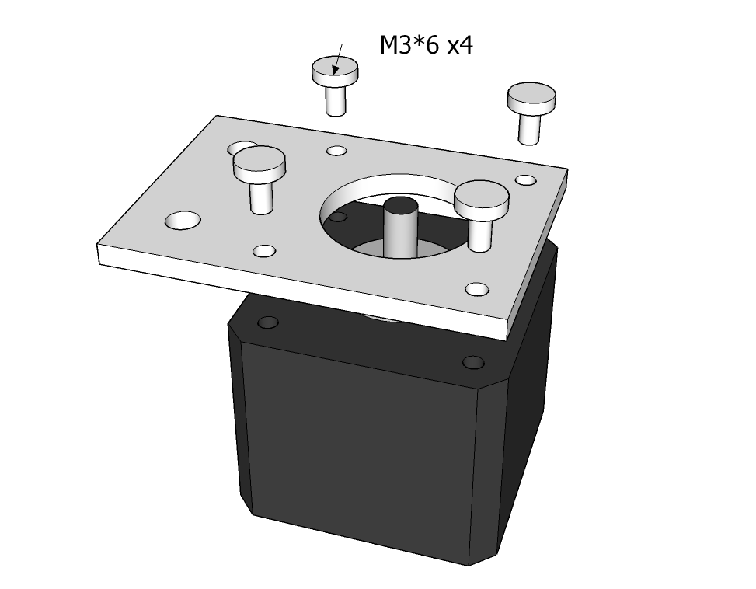
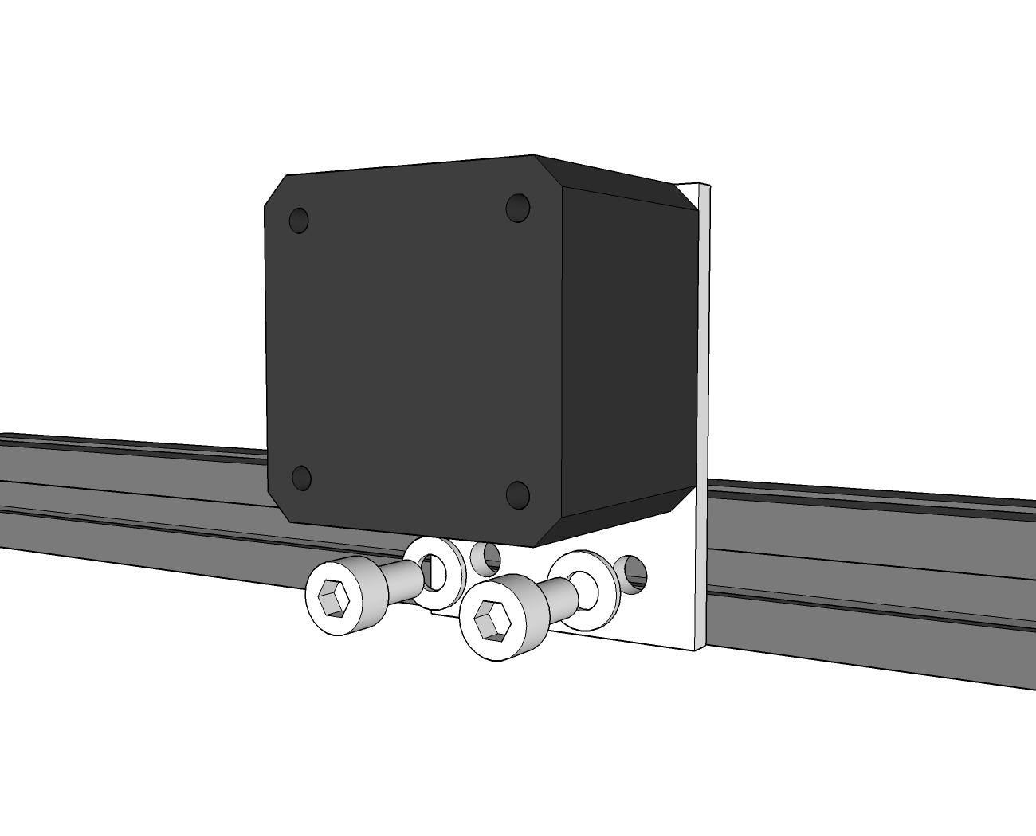
- X-axis & Z-axis
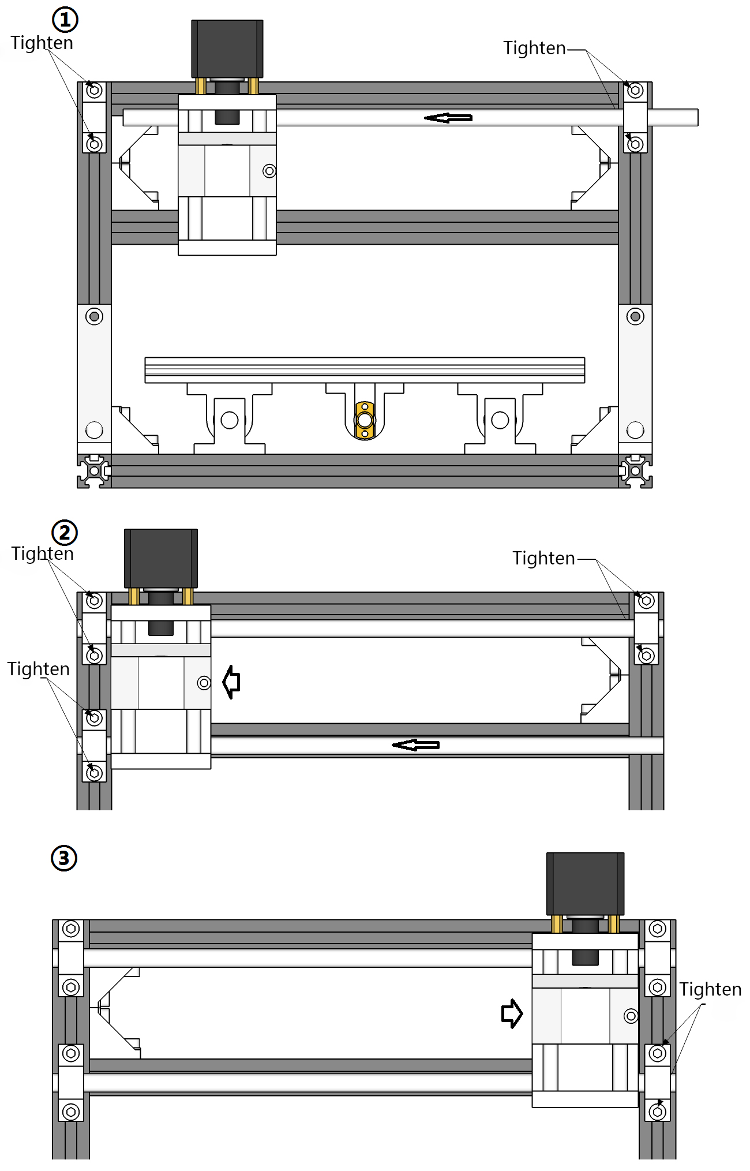
Lead screws installation
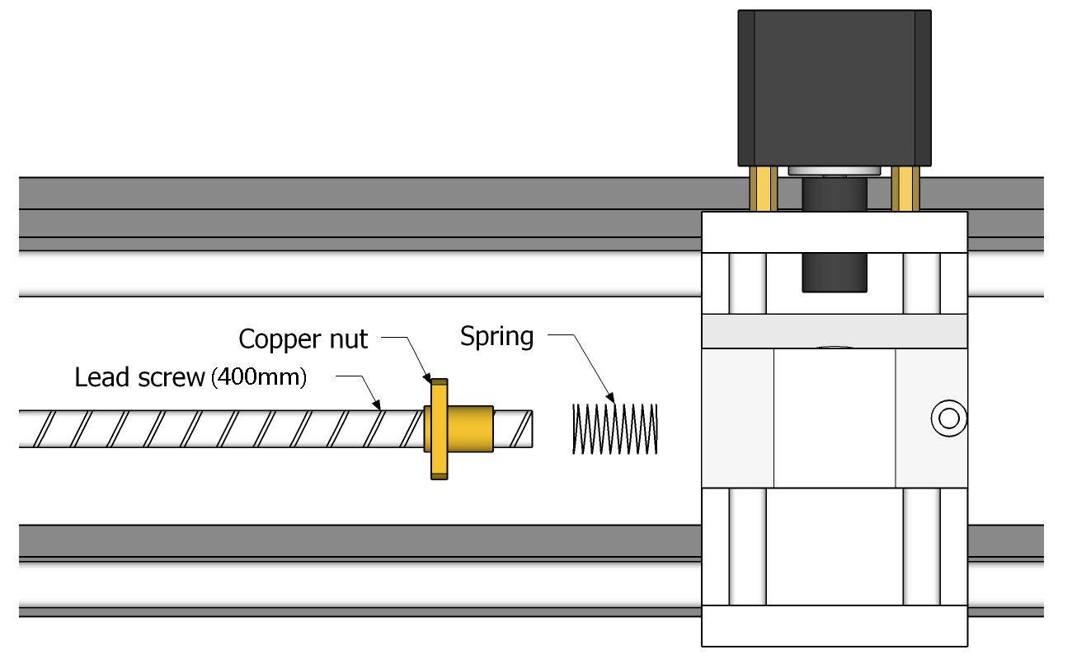
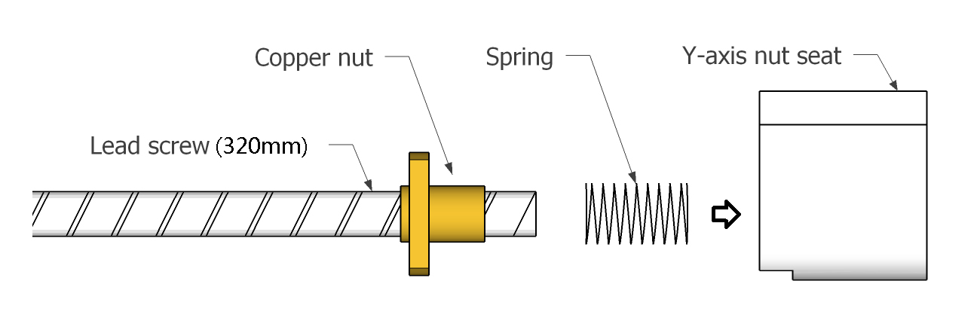
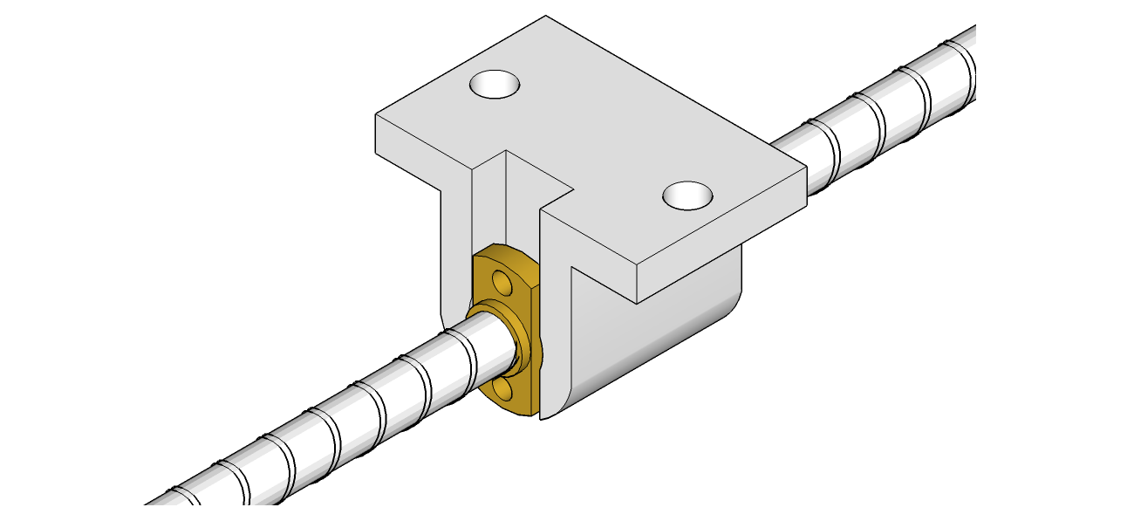
- Couplings Assembly:
Tighten two screws from one side only
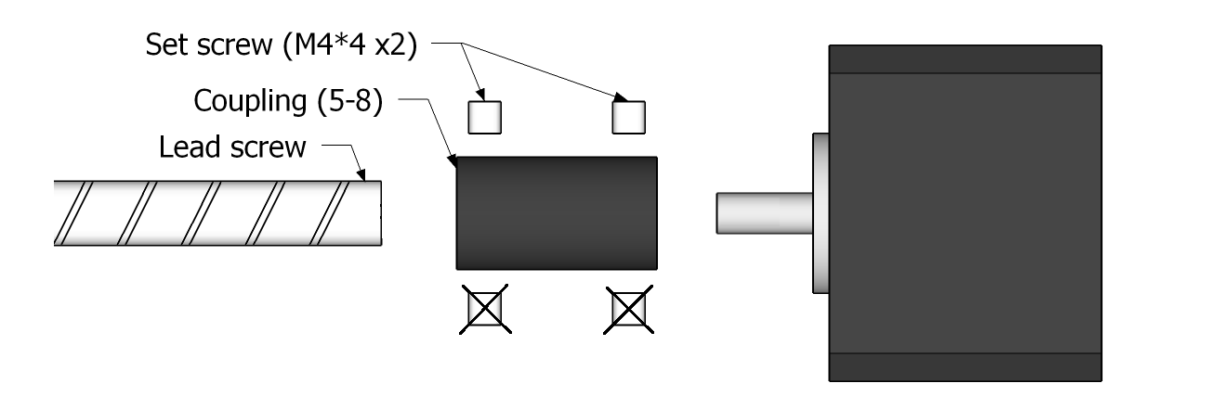
- Bearing Assembly:
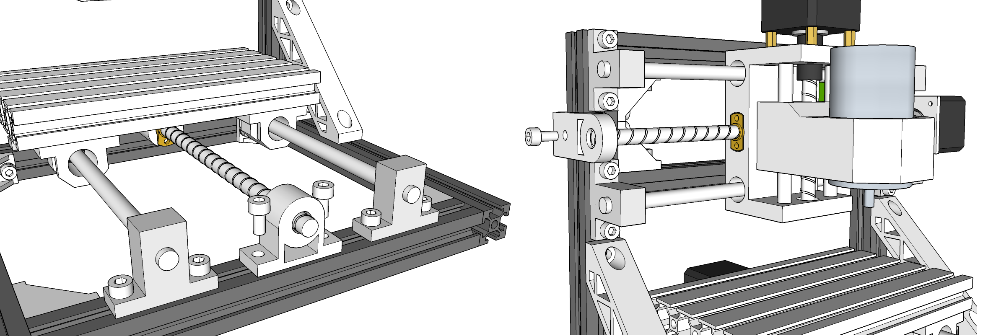
- Control board Assembly
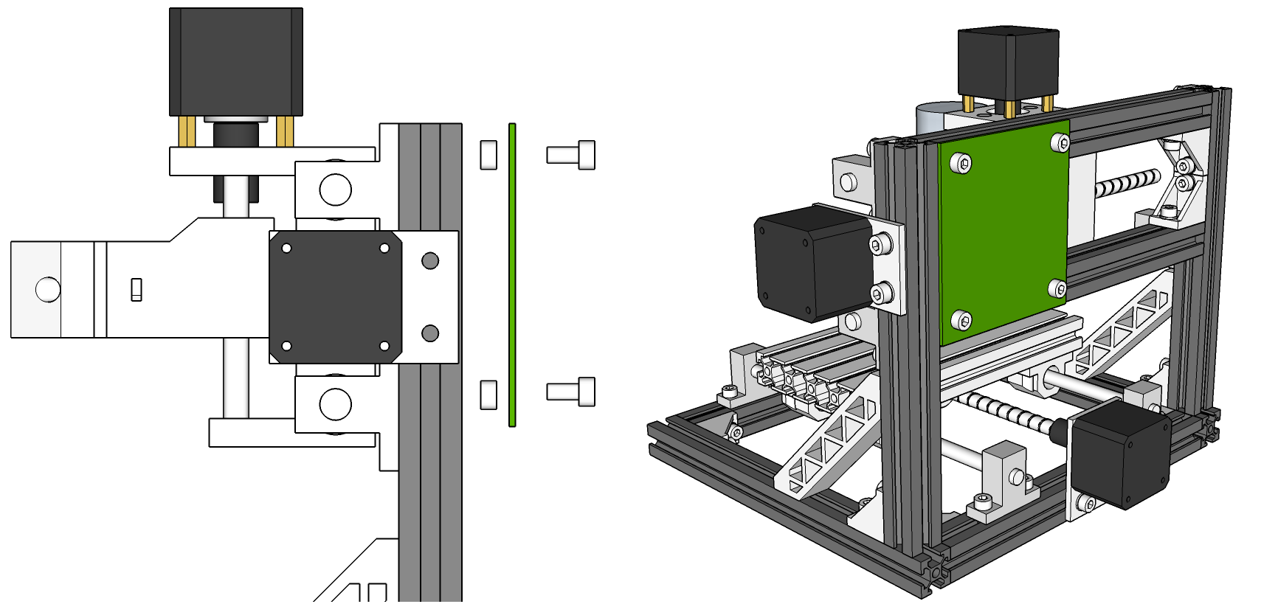
Wiring Diagram
